Hey, did you know CCAA is hiring?!?!
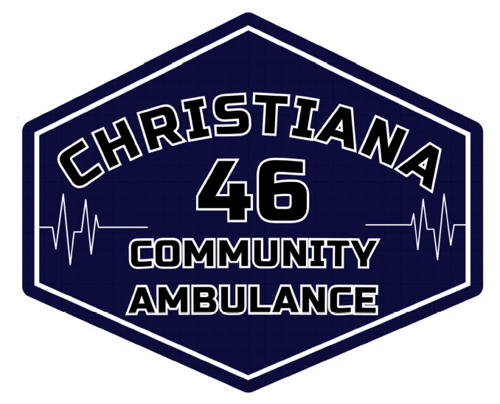

JOIN THE TEAM
Christiana Community Ambulance is accepting your resumes for:
- PARAMEDIC POSITIONS
- FULL AND PART TIME OPPORTUNITIES

Christiana Community Ambulance is currently searching for dedicated , highly motivated Paramedics who want to make a difference in our community.
Awesome Enviroment
You want it, we got it…
- Sapphire Infusion Pumps
- New ALS Vehicles
- In-House Trainings
- Excellent Benefits
- 12 and or 24 hour shifts
Send your resumes to:
chief46@christianaems.org

